DOCUMENTATION –

ZARZADZANIE SALAMI API

Author: Maciej Adamczyk, 2018r. (07-09.2018), E-mail: adamczyk.maciej01@gmail.com

# Requests Routes: (CONTENTS PAGE)

1. Buildings
2. Classroom functions
3. Campus
4. Classroom structures
5. Classrooms
6. Educational classrooms
7. Computers
8. Virtual machines
9. Virtual machines - computers
10. Monitors
11. Software
12. Computer software
13. Floors

## Buildings

* [api/buildings](https://localhost:44358/api/buildings) [GET]

***returns a list of all buildings***

* api/buildings/{id} [GET]

***returns a building with a specific “id”  
e.g. api/buildings/1 – returns a building with id = 1 (if exists)***

## Classroom functions

* [api/classroomFunctions](https://localhost:44358/api/classroomFunctions) [GET]

***returns a list of all classroom functions***

* api/classroomFunctions/{id} [GET]

***returns a classroom function with a specific “id”  
e.g. api/classroomFunction/1 – returns a classroom function with id = 1 (if exists)***

## Campus

* [api/campus](https://localhost:44358/api/campus) [GET]

***returns a list of all campus***

* api/campus/{id} [GET]

***returns a campus with a specific “id”  
e.g. api/campus/1 – returns a campus with id = 1 (if exists)***

## Classroom structures

* [api/classroomStructures](https://localhost:44358/api/classroomStructures) [GET]

***returns a list of all classroom structures***

* api/classroomStructures/{id} [GET]

***returns a classroom structure with a specific id  
e.g. api/classroomStructures/1 – returns a classroom structure with id = 1 (if exists)***

## Classrooms

* [api/classrooms](https://localhost:44358/api/classrooms) [GET]

**returns all classrooms together with educationalClassrooms parameters (for all classrooms)**

* api/classrooms?SearchCategory=..&Search=..&Buildings=..&TV=..&Projector=..&AirConditioning=..&OnlyEducationalClassrooms=..&ClassroomFunctions=..&AccessForTheDisabled=.. &SizeMin=..&SizeMax=..&PlacesMin=..&PlacesMax=.. [GET] **- Parameters: Buildings, ClassroomFunctions can have multiple values (FILTERING)**

***returns a classroom with specific features (FILTERING)***

* api/classrooms/{id} [PUT] computer id param in body of request

**for binding a classroom with a computer**

***updates the id of the computer in the classroom with a specified id in the URI***

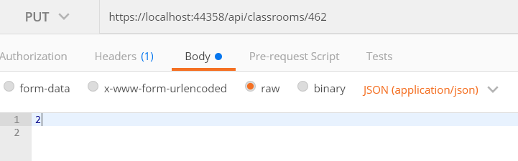

* api/classrooms [POST]

**creates a classroom, (no id of a classroom, it’s auto-generated)**

CzyDydaktyczna = false

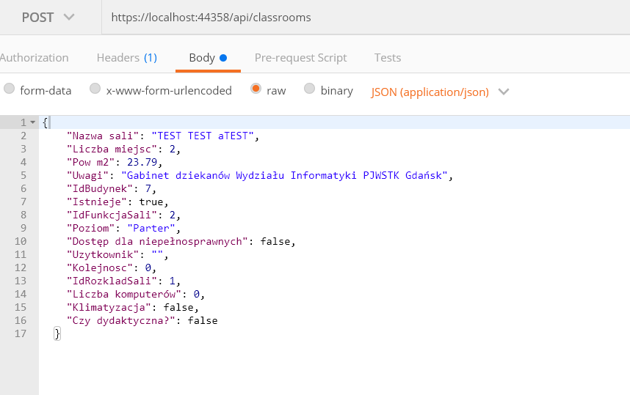

OR CzyDydaktyczna = true

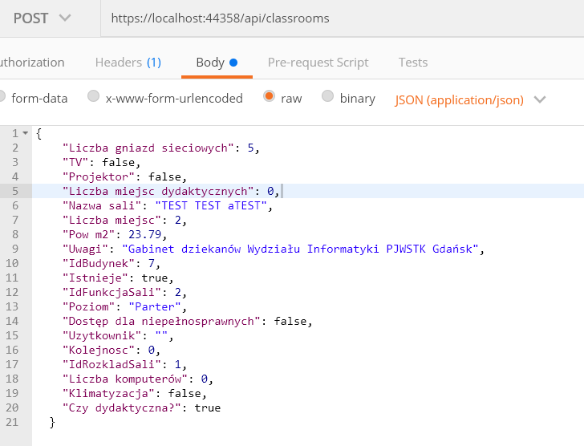

* api/classrooms [PUT]

**updates a classroom, if we want to update an educationalClassroom then we have to add a parameter CzyDydaktyczna=true**

CzyDydaktyczna = false

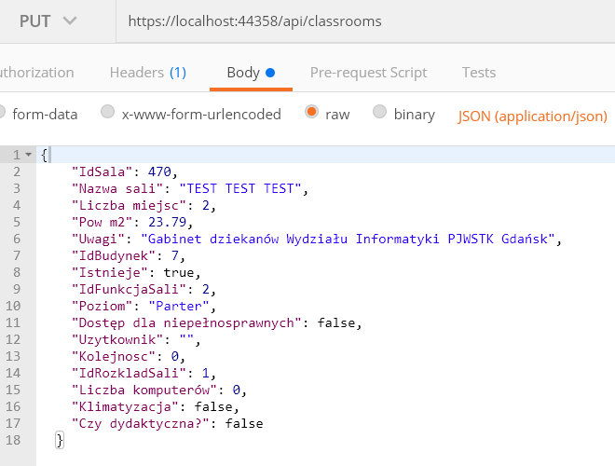

Or “Czy dydaktyczna” = true

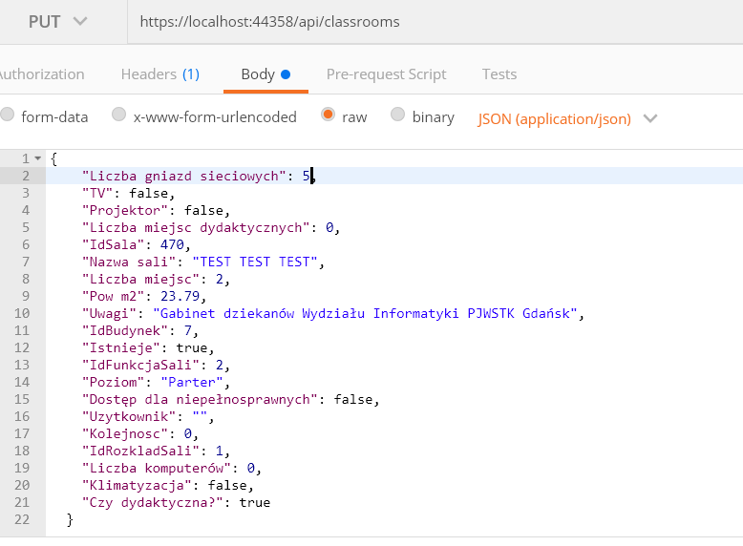

## Educational Classrooms

* [api/educationalClassroms](https://localhost:44358/api/educationalClassrooms) [GET]

***returns a list of all educational classrooms***

* api/educationalClassroms/{id} [GET]

***returns an educational classroom with a specific id***

## Computers

* [api/computers](https://localhost:44358/api/computers) [GET]

***returns a list of all computers***

* api/computers/{id}

***returns a computer with a specific id***

* api/computers [POST]

***creates a computer together with assignment of virtual machines, software***

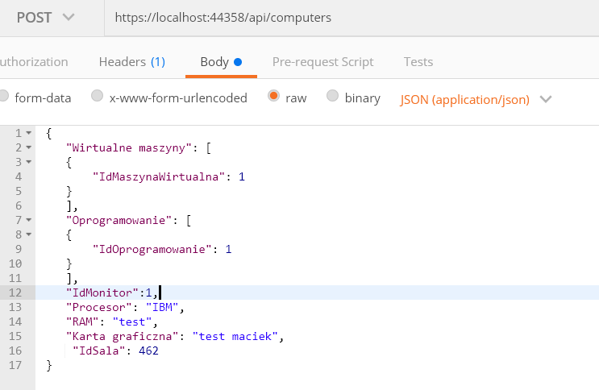

* api/computers [POST]

**for adding a computer , we don’t have to specify id of a computer**

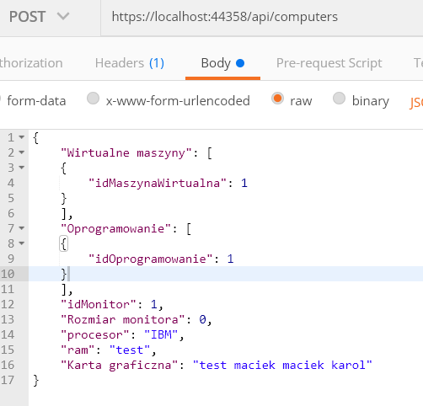

* api/computers [PUT]

***updates a computer***

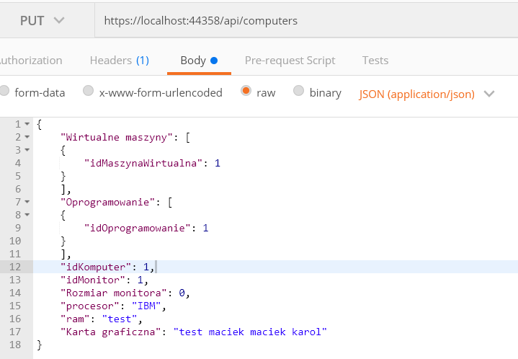

## Virtual Machines

* [api/virtualMachines](https://localhost:44358/api/virtualMachines) [GET]

***returns a list of all virtual machines***

* api/virtualMachines/{id} [GET]

***returns a virtual machine with a specific id***

## Virtual Machine Computers

* [api/virtualMachineComputers](https://localhost:44358/api/virtualMachineComputers) [GET]

***returns a list of all virtual machines bound up with computers and vice versa***

## Monitors

* [api/monitors](https://localhost:44358/api/monitors) [GET]

***returns a list of all monitors***

* api/monitors/{id} [GET]

***returns a monitor with a specific id***

## Software

* [api/software](https://localhost:44358/api/software) [GET]

***returns a list of all software***

* api/software/{id} [GET]

***returns software with a specific id***

## Computer Software

* [api/computerSoftware](https://localhost:44358/api/computerSoftware) [GET]

***returns software bound up with computers***

## Floors

* [api/floors](https://localhost:44358/api/FLOORS) [GET]

**returns a list of all distinct floors**